LAB 01

**Question 1: Execute all the commands discussed in this lab. Solution:**

* Date:



* Cal:

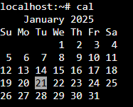

* Echo:



* Ls:



* Whoami:



* Uptime:



* Uname:



* Hostname:



* Bc:

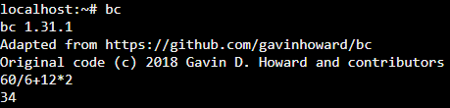

* Cat:

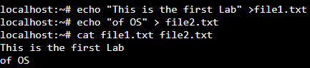

* Rm:

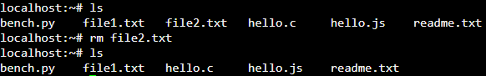

* Wc:

